**Requested Analysis #1**

**5/24/17**

We need to perform an analysis to determine the changes in the vehicle’s inertia matrix due to structural deformation. I have performed such an analysis for our given structure, but I am asking you to perform the same analysis while varying the structural stiffness, and tabulating and plotting the results.

An example analysis is outlined as follows:

1. Place the data files in mAEWing2_FEMv1p2.mat in your MATLAB path, and place the data files in AEClong3_mW2.mat and RBaero.mat in the Workspace.
2. Execute the function trim_flex.m to solve for the trim values in the output array ‘Y’ [AoA, Dele4, eta1, eta3, and eta5] at three flight velocities [23, 25, 28 m/s]. AoA and Dele4 are in radians, etas are dimensionless. Save the results in a .mat file named ‘Trim_Results.mat’ containing the trim array ‘Y’, and also plot the trim results. For example,

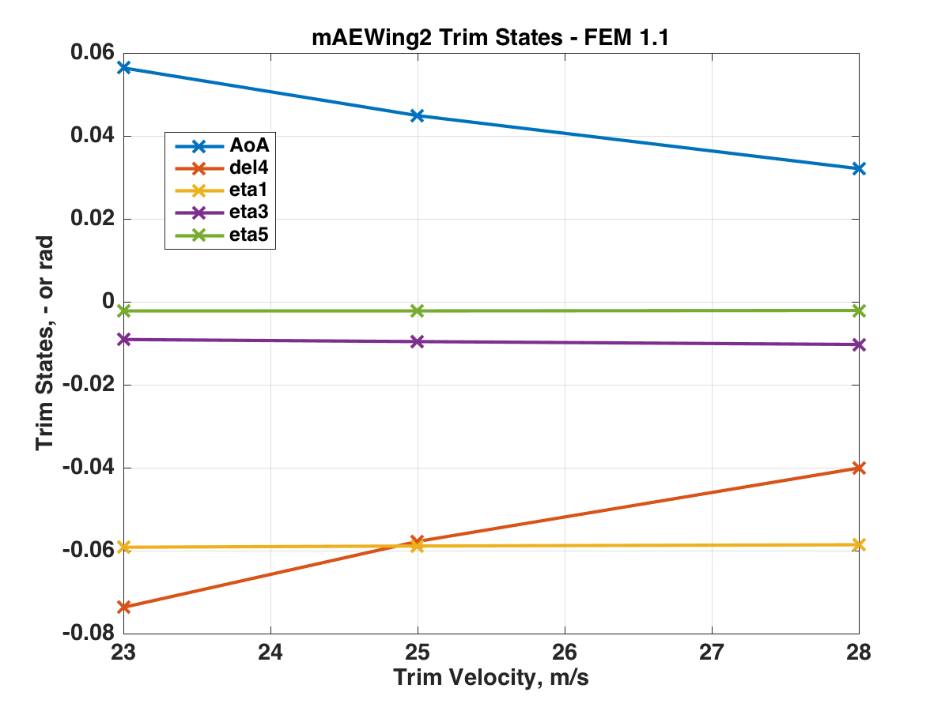

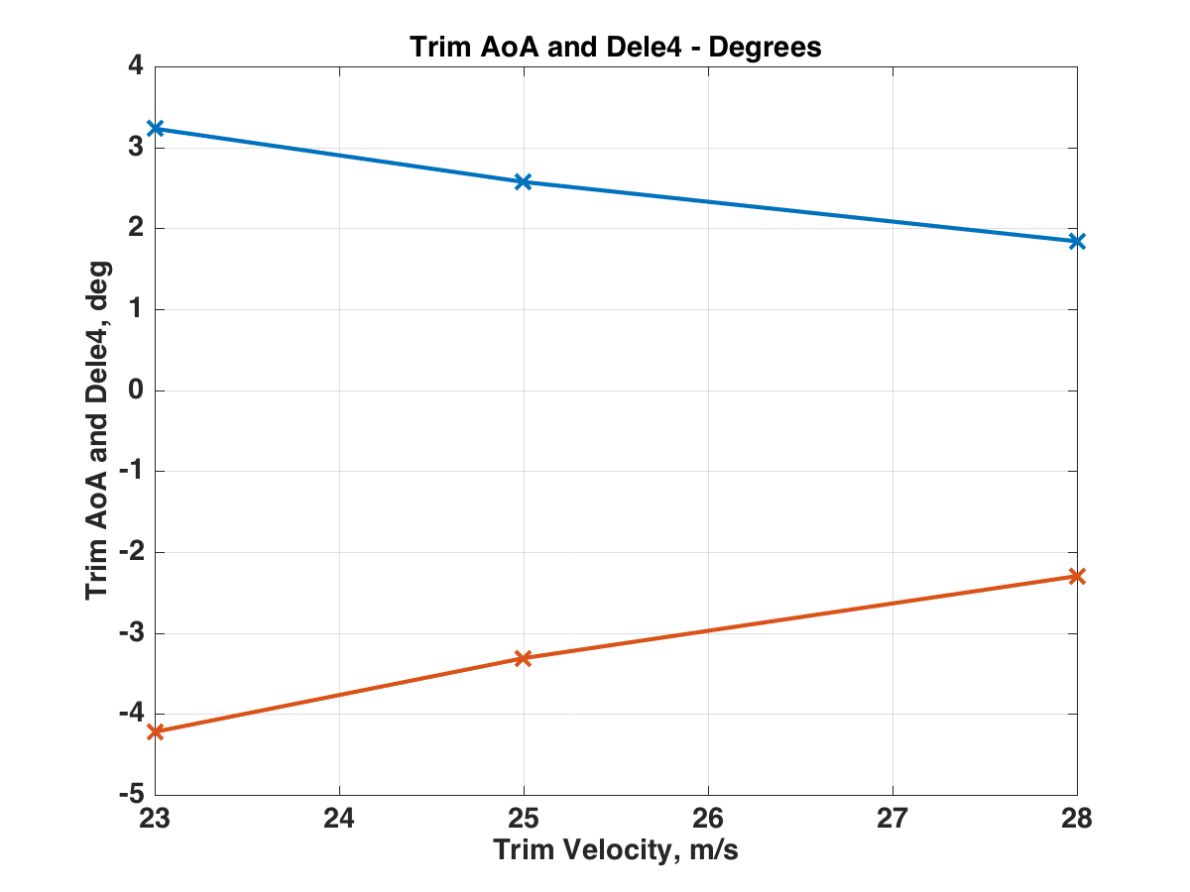

1. Place the data files in ‘DeltaMatrices.mat’ in the Workspace, and execute the script ‘Trim_Inertias.mat’ to find the three 3x3 inertia matrices Jrigid, DeltaJ, and DeltaJ2. And the total inertia matrix is the sum of these three matrices, and the change in the inertia matrix is the sum of DeltaJ, and DeltaJ2. For example,

Jrigid in lb-in2 =

2.9283e+04 1.1416e-05 -3.2870e+02

1.1416e-05 4.0420e+03 -1.8735e-05

-3.2870e+02 -1.8735e-05 3.2923e+04

and at 28 m/s

Jtotal in lb-in2 =

2.9283e+04 -9.1365e-04 -3.2870e+02

-9.1365e-04 4.0420e+03 2.0266e-03

-3.2870e+02 2.0266e-03 3.2923e+04

while the change in the inertia matrix is

Change in J in lb-in2 =

4.0702e-03 -9.2507e-04 2.0037e-03

-9.2507e-04 4.1497e-03 2.0454e-03

2.0037e-03 2.0454e-03 8.4147e-05

We can see that in this case the structural deformation essentiall only affects the four small terms in the rigid inertia matrix.

Now I first suggest that you follow the above procedure to make sure we both get the same results. Then parametrically scale the structural stiffness by reducing the three frequencies in the ‘omega’ array defined in Line 9 in the function ‘trim_flex’. (Stiffness is proportional to the square of these frequencies.) I suggest reducing all three omegas by some fixed factor (e.g., 0.5) simultaneously, performing the above calculations, and plotting the results. We want to reduce these frequencies until we get at least a 5% change in the (2,2) element in the inertia matrix (currently the nominal value of the term is 4042 lb-in2. And the answer we seek is the required reduction in stiffness, as a factor of nominal, to obtain at least a 5% change in J(2,2).

Let me know if you have questions, and we can discuss on Hangouts.